Install Prometheus and Grafana on a Linux EC2 machine, connect Prometheus to Grafana, and create a dashboard to view metrics.

Install Prometheus
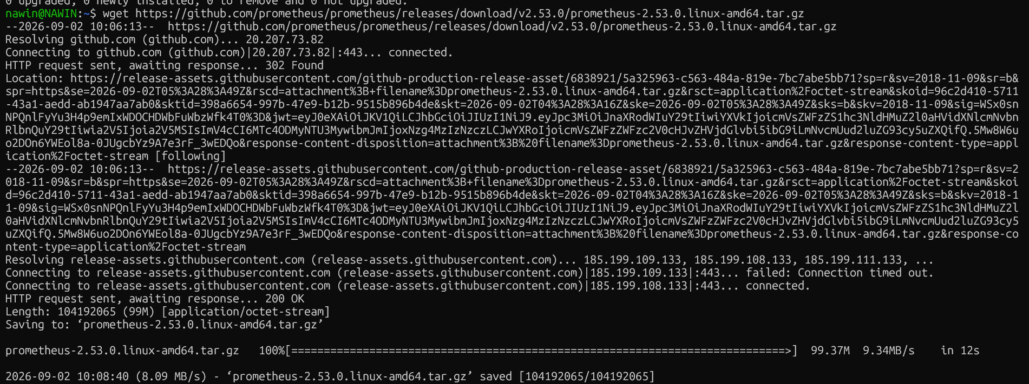

Run Prometheus:

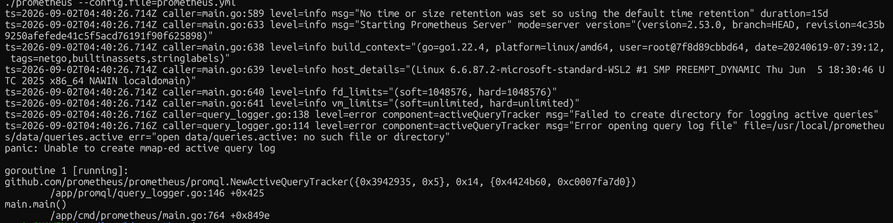

Install Grafana
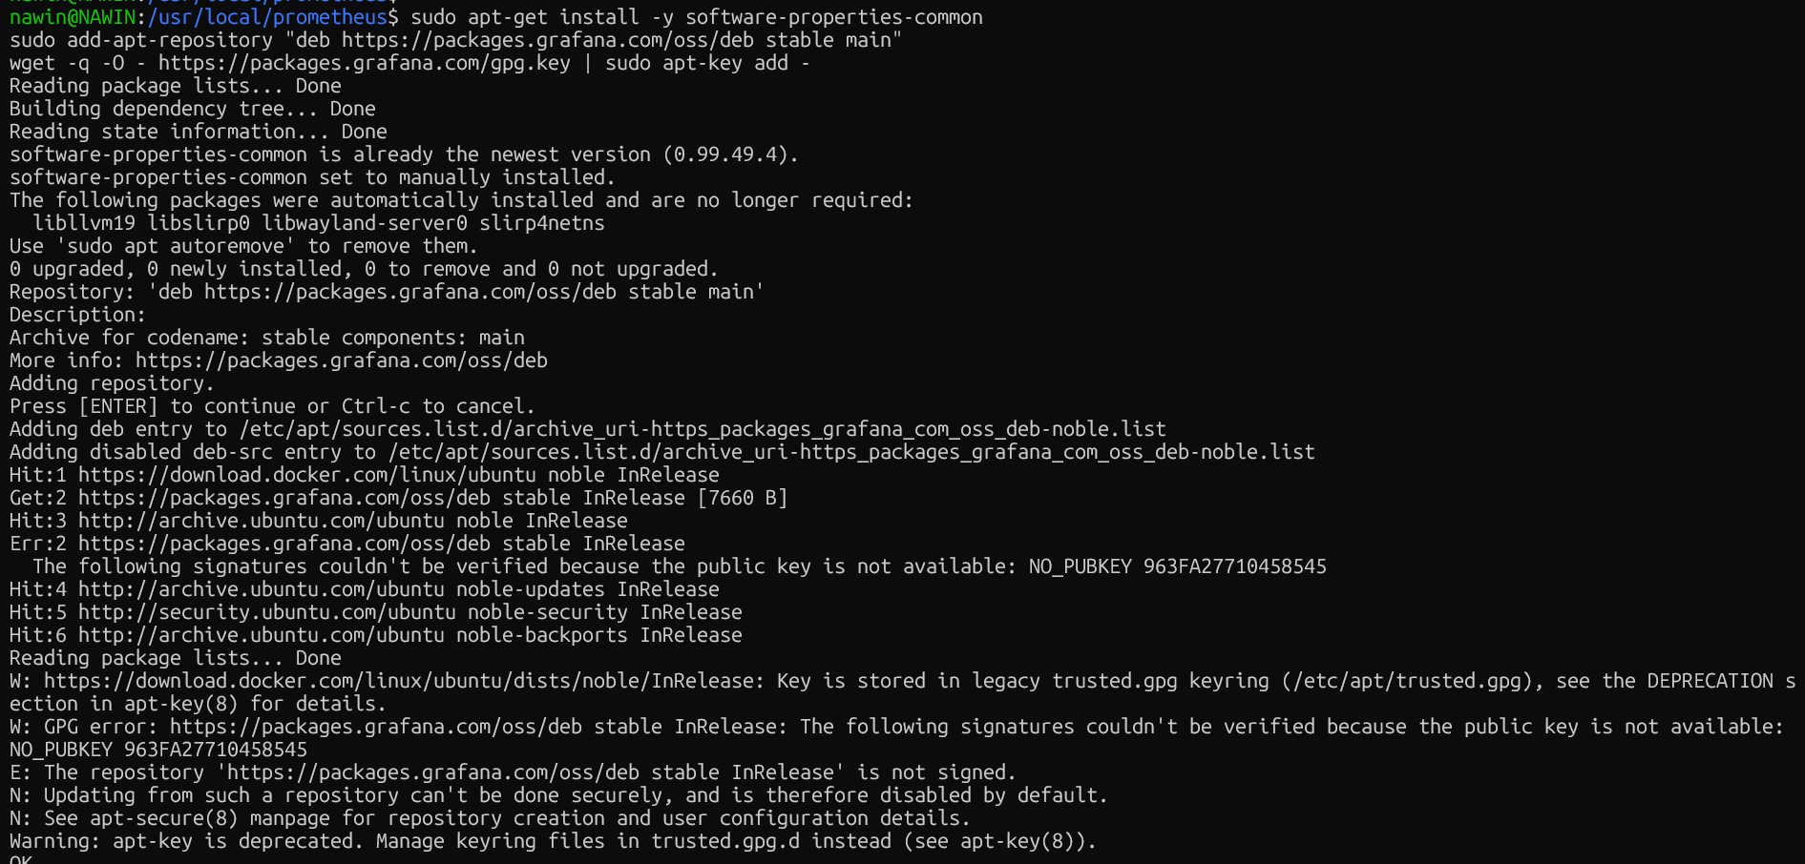

Grafana Service status

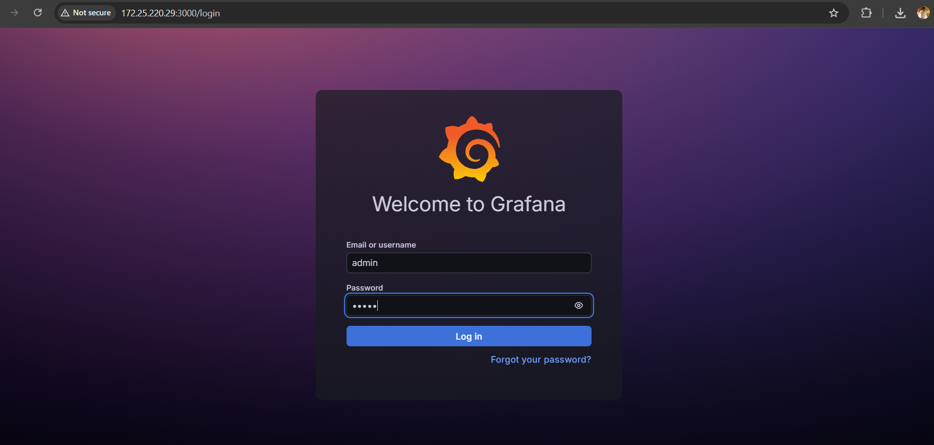

Prometheus Configuration:
CPU
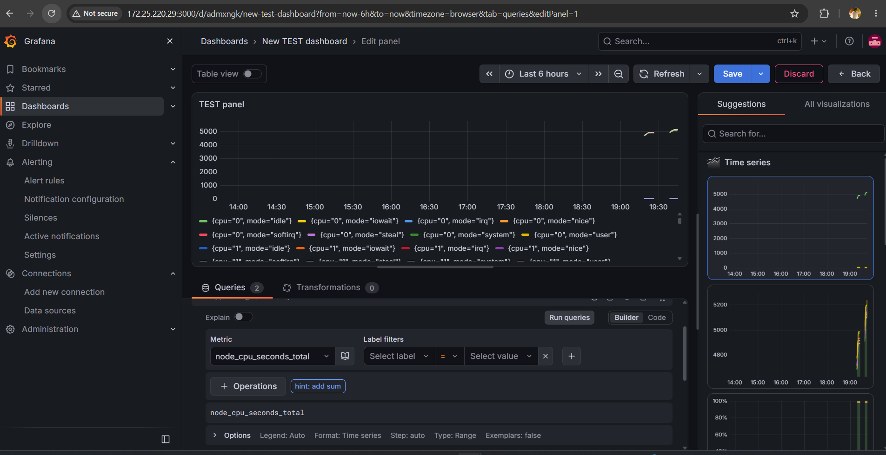

Memory
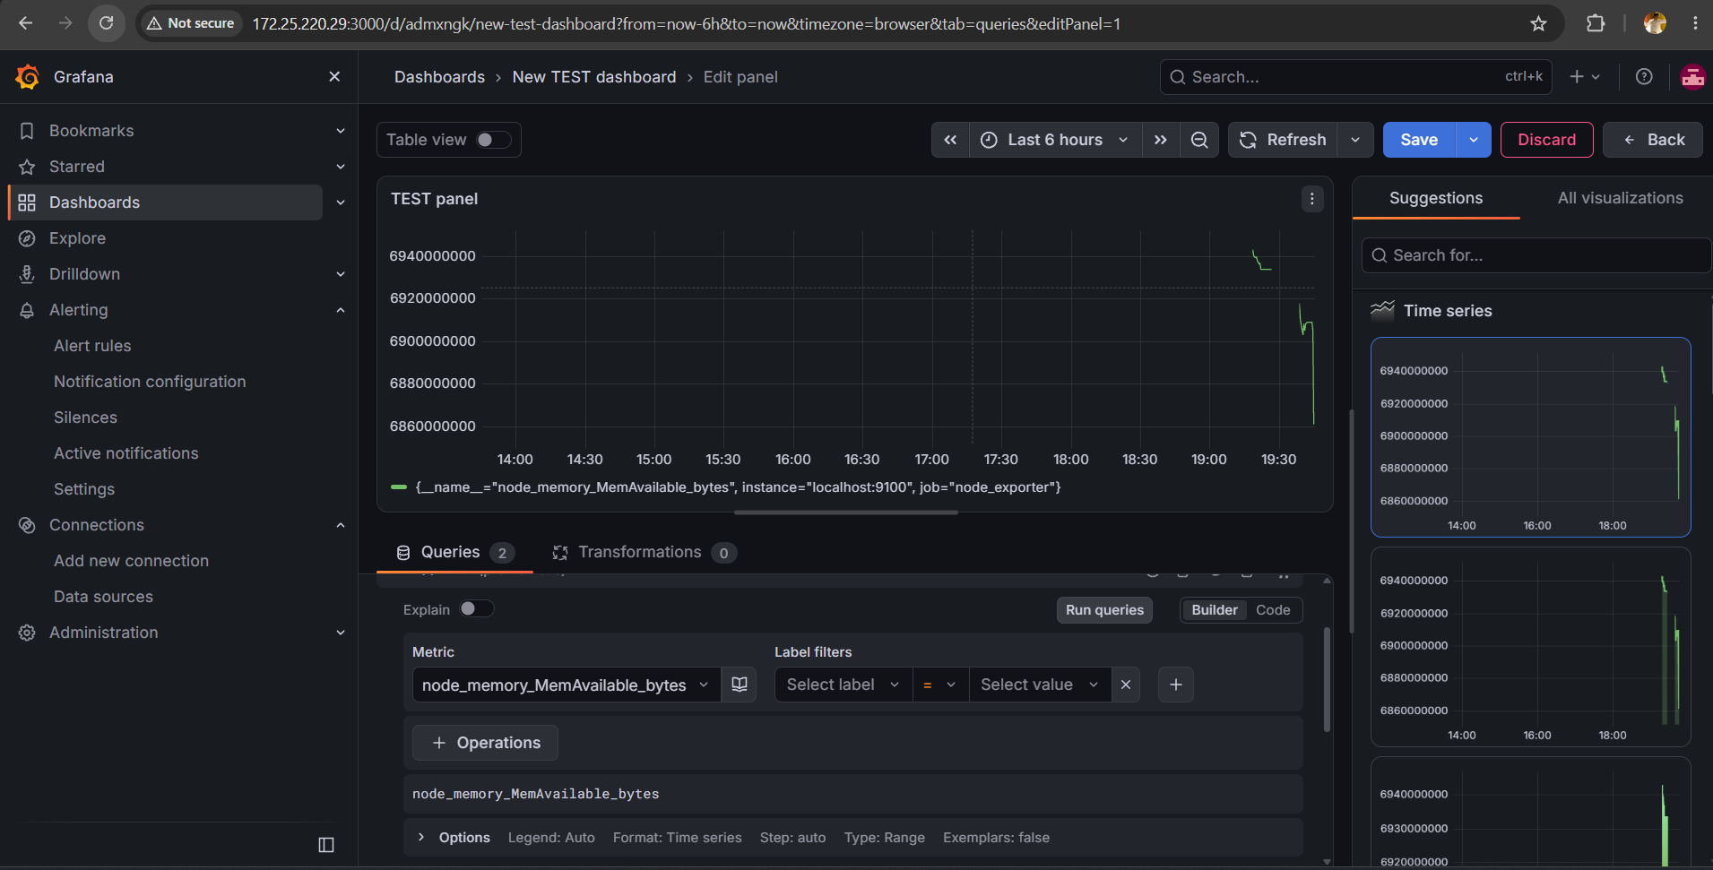

Network
